Volume®

Documentation Style Guide

**V**

Table of Contents

Introduction 3

Company and Product Names 3

Color Usage 3

Page Styling 4

Page Size 4

Page Layout 4

Text Styling 5

Headings 5

Body Text 6

Graphics 8

Logo 8

Screenshots 8

GUI Elements 8

# Introduction

The *Volume Documentation Style Guide* supplies guidelines for creating consistent and professional Volume documentation. Writers, designers, and all other roles involved in developing internal or external Volume documentation must adhere to this style guide.

## Company and Product Names

Volume is a company that specializes in statistical software. Follow these guidelines when referencing the Volume brand, products, and features.

* Use **Volume** to refer to the company. Avoid “Vol.”
* Use **VolumeStat**, **VStat**, or **VS** to refer to the statistical software. Do not use spaces in any variation. Always capitalize the V and S.
* Use **VolumeLang**, **VLang**, or **VL** to refer to the programming language built in VolumeStat. Avoid “VolumeL.” Do not use spaces in any variation. Always capitalize the V and L.
* Only use the reserved symbol for the “Volume” name on the cover page.

## Color Usage

Use the color palette below for all documentation. For a reference on which colors to use for which text, see Text Styling. Only use colors not included in the palette for screenshots or GUI elements that require them (see Graphics).

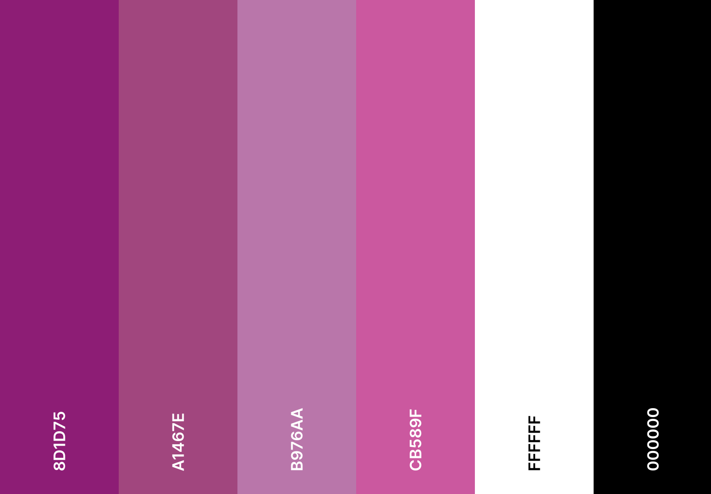*Volume’s color palette*

# Page Styling

## Page Size

For page size, all documents must use the standard letter format of 8.50″ by 11.00″ in portrait orientation.

## Page Layout

Follow the guidelines below for standard page layout in all documentation.

### Margins

All documents must use 0.75″ margins with no gutter.

### Headers

The header should include the page number aligned to the right. Do not include the page number on the cover page or table of contents; keep those headers blank.

### Footers

The footer should include the spelled-out “Volume” name in #8D1D75 40-point Cambria aligned to the left, and the chapter name the page belongs to aligned to the right.

### White space

Utilize white space for a clean and easy-to-read presentation. Always separate sections by a single space. For tables, use 0.04″ padding on all sides.

# Text Styling

## Headings

**Headings** refer to titles that hold and summarize grouped content, such as chapters.

Heading Conventions

|  |  |  |
| --- | --- | --- |
| **Heading Level/Type** | **When To Use** | **Font Style** |
| Heading 1 | Chapters titles. | Bold #000000 40-point Arial with a #8D1D75 4.5-point bottom border that extends the width of the page. |
| Heading 2 | Sections titles. Sections are found inside chapters. | Bold #A1467E 24-point Arial. |
| Heading 3 | Subsection titles. | Bold #000000 18-point Arial. |
| Content Heading 1 | In the table of contents to refer to chapter titles. | Bold #000000 14-point Arial. |
| Content Heading 2 | In table of contents to refer to section titles. Subsection titles are not included in the table of contents. | Regular #000000 14-point Arial. |
| Table Heading | For table titles. | Italic-bold #000000 14-point Arial. |

## Body Text

**Body text** refers to the textual content inside each chapter, section, subsection, or table. Regular body text should use #000000 12-point Arial font without added text decoration. See the *Typographic Conventions* table for cases where special text requires specific colors or decoration.

Font Conventions

|  |  |  |
| --- | --- | --- |
| **Font** | **When To Use** | **Example(s)** |
| Arial | Regular text. Size 12-point. |  |
| Cambria | Use for the Volume name and logo on the cover page and footer of documentation. Use size 100-point on the cover page. Always use bold. |  |
| Cascadia Code | VolumeLang code samples and function names. | // imports a dataset from a CSV file  csv_data = import_csv(“data.csv”)  The plot function creates visualizations of a given dataset. |

Typographic Conventions

|  |  |  |
| --- | --- | --- |
| **Scenario** | **Style** | **Example(s)** |
| Introduce new terminology or Volume product or highlight the text of a GUI element. | **Bold** | A **function** is a reusable block of code.  To save your project, select **Save**. |
| Table names, figure captions, or emphasizing important text. | *Italics* | See the *Commands* table for supported commands. |
| [URL](http://fakesite.com/) or cross references. | Underlined, #CB589F | To learn how to import different types of data, see [Importing Data](http://importindata.com/). |

# Graphics

## Logo

Only include the logo on the cover page unless it’s needed elsewhere to achieve the document’s purpose. All documentation should only include the default logo design on the cover page. The default design is a #8D1D75 cylinder with a #B976AA top face and a bold white **V** in Cambria font on the curved surface.

Avoid all official and unofficial alternative logo designs, such as the inverted logo. Alternative designs are for marketing only.

**V**

**V**

Default logo Inverted logo

✓ ✗

## Screenshots

Only use screenshots when navigating a user interface that the reader is unfamiliar with. Because screenshots consume more space and need replacement screenshots whenever VolumeStat updates, use them sparingly.

## GUI Elements

To help the reader find a GUI element on the screen, insert the element’s symbol after the element name in the text guide.

**Example:** To execute your code, select **Run**

# Conclusion

The Volume style guide is your go-to reference for all documentation writing needs. Follow the guidelines to create friendly but dignified tutorials, guides, and reference material. Refer any style questions not mentioned in this style guide to an experienced Volume writer or editor.